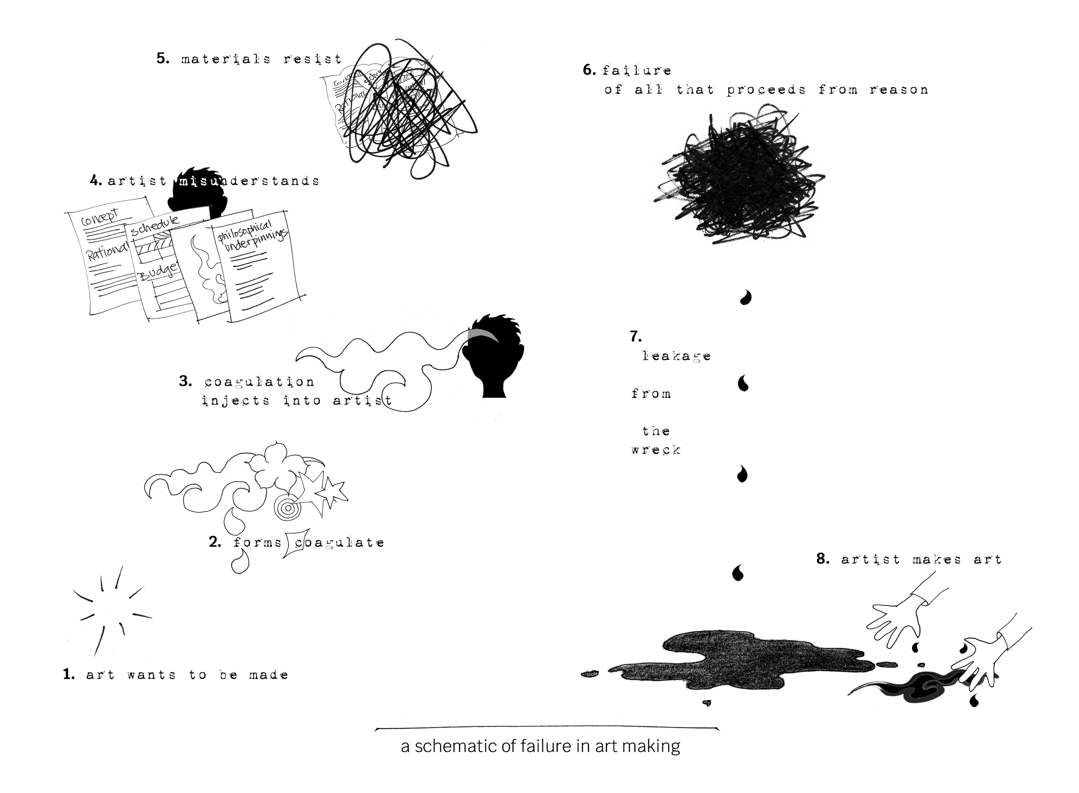

Figure 7.1: A Schematic of Failure in Art Making. Source: Linda Dement. Used with permission.